1. **What is a software?**

A software is a set of programs.

2. **Types of software.**

* **System software.**
* This usually contains software programs that machine uses to operate. For example; windows , linux etc.
* **Application software.**
* This is contained of carrying out specific tasks that are commanded by the user. For example; adobe photoshop, autocad etc.
* **Driver software**
* Driver software is a type of computer program that enables communication between the operating system and a specific hardware device, such as a printer, graphics card.
* **Custome software**
* Custom software refers to programs or applications that are specifically designed and developed to meet the unique needs and requirements of a particular organization, business, or individual.
* **Packaged software**
* Packaged software refers to pre-written, commercially available software that is sold or distributed as a complete package.
* **Educational software**
* A type of software used for teaching or self-learning.

3**.What is SDLC?**

SDLC stands for Software Development Life Cycle. It's a structured process that outlines the stages or phases involved in developing software. These stages typically include planning, designing, implementing, testing, deploying, and maintaining software. The goal of SDLC is to produce high-quality software that meets customer expectations, is delivered on time, and stays within budget. Different methodologies, such as Waterfall, Agile, and DevOps, provide frameworks within which SDLC operates, each with its own approach to managing the software development process.

**Phases of SDLC?**

**Planning:** In this initial phase, project goals, requirements, feasibility, and resources are assessed. It involves understanding the scope of the project, defining objectives, and creating a project plan.

**Requirement Analysis:** This phase involves gathering and analyzing user requirements, functionalities, and features that the software should have. It helps in understanding what the end-users expect from the software.

**Design:** Once the requirements are clear, the system architecture and design are developed. This phase involves creating high-level and detailed designs for software components, databases, interfaces, and more.

**Implementation or Development**: The actual coding or development of the software happens in this phase. Programmers write code according to the design specifications. This phase involves translating the design into a functioning system.

**Testing:** After development, the software is tested to ensure that it meets the requirements and works as expected. Different types of testing (unit testing, integration testing, system testing, etc.) are performed to identify and fix bugs or issues.

**Deployment**: Once testing is completed and the software is deemed ready, it is deployed to the production environment for users to access and use.

**Maintenance and Support**: After deployment, the software enters the maintenance phase. It involves fixing issues that arise post-deployment, making updates or enhancements based on user feedback, and ensuring the software functions smoothly.

**4.What is DFD**?

DFD in full is Data Flow Diagram. It's a graphical representation used in software engineering and systems analysis to depict the flow of data within a system.

**Dfd of filpkart.**

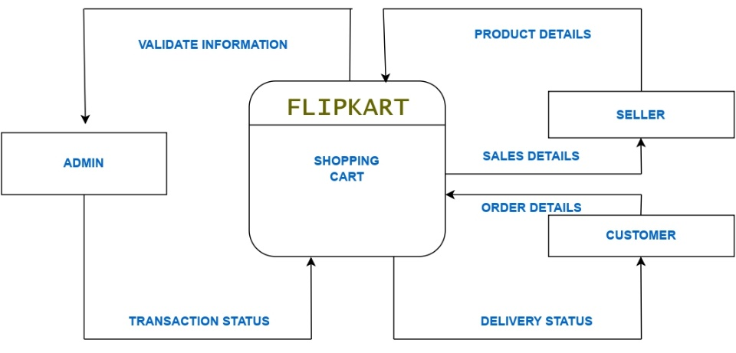

5.**What is a flowchart?**

A flowchart is a visual representation of a process or workflow, using different shapes and arrows to illustrate the steps involved in completing a task or achieving a goal.

**Flowchart of addition of 2 numbers.**

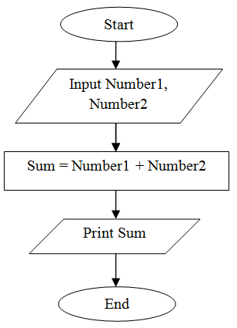

**6.What is use case diagram?**

A Use Case Diagram is a type of visual representation in Unified Modeling Language (UML) used in software engineering to describe the interactions between a system (software) and its users or other systems.

**Use case diagram of paytm.**

